New York State Immunization Information System
Camp Access User Training

Introduction
Welcome to the Camp User Training for the New York State Immunization Information System.
NYSIIS is a secure and confidential web-based immunization information system. As of January 1, 2008, Public Health Law requires all immunizations administered to persons less than 19 years of age to be entered into NYSIIS within 14 days of administration. This includes the immunization histories for that patient, if not previously reported.

Training Overview
- Introduction to NYSIIS
- Summary of mandate
- Benefits of a web based system
- User role
  - Camp Access User: The camp access user is able to search for campers in NYSIIS, generate immunization history reports for campers, and create camper lists to be used for reporting purposes.

Training Objectives
At the completion of school user training, participants should be able to:

- Search campers entered into NYSIIS from multiple sources (provider offices, public agencies, registry upload, or vital statistics)
- Create and manage camper lists to be used for reporting purposes
- Access, run and print the camper immunization history report

- Other Training Resources
- Online tool – light bulb
- User manual
- Help desk (Phone: 1-866-389-0371 or Email: nysiishelpdesk@dxc.com)

V. Accessing NYSIIS via NYSDOH Health Commerce
System (HCS)

Enter the Web Address: https://commerce.health.state.ny.us
- Log in to the HCS Portal
- First time users must add the NYSIIS application to the My Applications section of the HCS Portal. This only needs to be added once and will remain in My Applications for all future access.
  - From the top navigational bar, click on My Content then choose All Applications.

  - Click on the letter “N” and scroll down to locate NYSIIS-Production.
  - Click on the green plus sign (+ ) to the far right.

  - The application will now automatically appear on the left side bar under My Applications on the HCS Homepage.

- To access NYSIIS click on the NYSIIS-Production link in My Applications.
- HCS Account Information:
- 10 unsuccessful login attempts before your account is locked
- If your account becomes locked, you must call Commerce Accounts Management Unit (CAMU) at 1- 866-529-1890 to have it enabled and to get a new password.
- Re-login every 4 hours
- Account is disabled after 5 months if no activity
- New password every 60 days

Identifying NYSIIS Tools, Windows and Menus
- Orient by yellow bar on top
- Resources and information found on top of screen

VII. GENERAL NYSIIS Application
- Left side menu overview
      - Find camper
      - Manage lists
        - Camper reports
      - Check camp report

VIII. Campers
- Find camper
      - Search: Select “find camper” from the side menu to search for a camper. Remember the 3 – 2 rule—minimally the first 3 letters of last name and first 2 of first name.

2. If multiple matches are detected, a screen presents possible matches.

3. Viewing a camper’s immunization history page

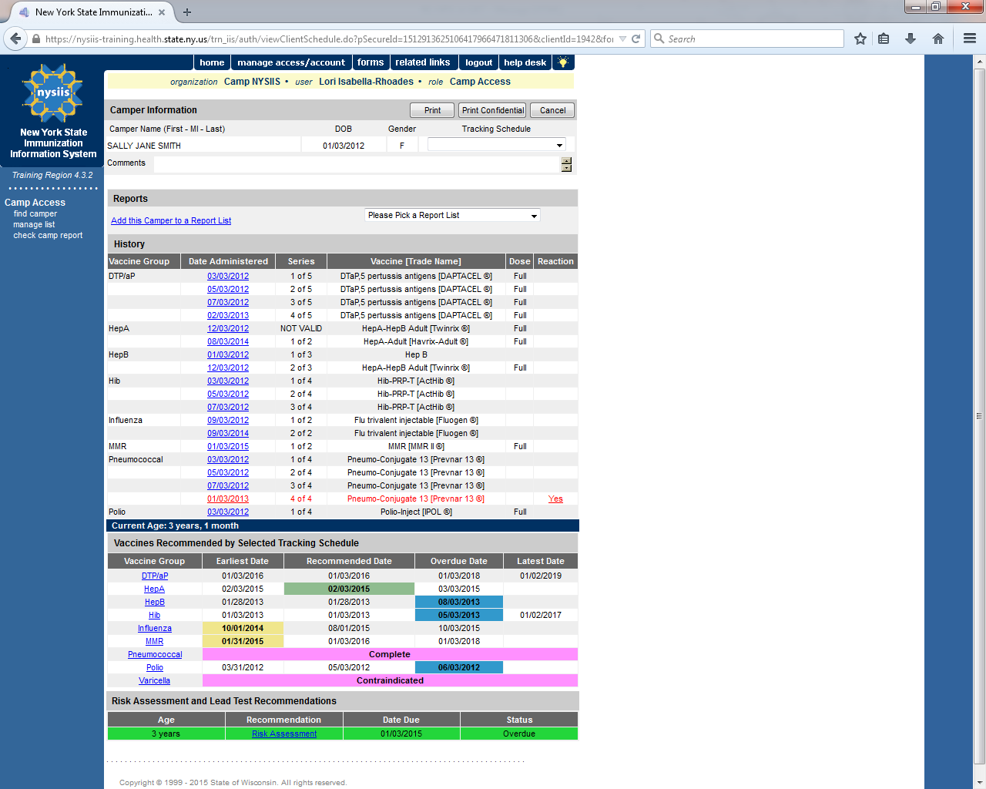

a. Camper Information
- Add to report list
  - Add campers to lists you have already created in NYSIIS
b. Immunization History
- Vaccine Group
- Date administered
- Series
- Trade name
- Dose
- Reaction
  - This column represents any reaction the camper had after receiving the vaccine. A “yes” in this column indicates there was a reaction. To view the detail, click the hyperlink.

c. Recommended Vaccines
- Yellow: earliest date allowed
- Green: recommended date range
- Blue: overdue date range
- Pink: no longer recommended

IX. Managing Lists
- Manage List
  - Add new report list names
  - Each camp can have up to 10 report lists at a time
- Report List
- Displays a table of all the camp’s saved lists
  - List name
    - Click to display camper’s within the list
  - Last updated date
  - Camper count
  - Delete

****NOTE - Once a list is deleted you cannot reverse the deletion. Deleting a list removes all campers from that list.

X. Camper Reports
- Camper List - displays the name and date of birth for the campers within the list. Names are sorted alphabetically by last name.
- Camper Immunization History List - displays the camper name, date of birth, the organization name and address that last entered an immunization into the camper’s record, immunization history, and recommended vaccines for each camper in the list.

